**EXPERIMENT : 8**

**BPO ORGANIZATION**

USE CASE DIAGRAM

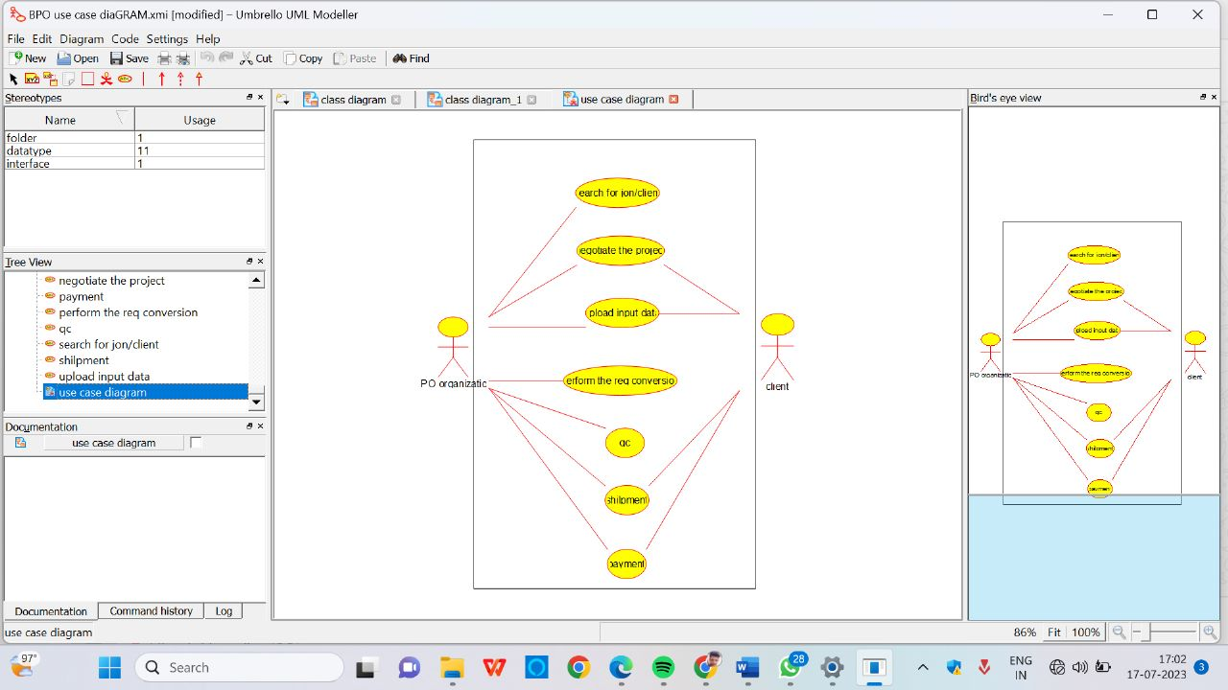

COLLABARATION DIAGRAM

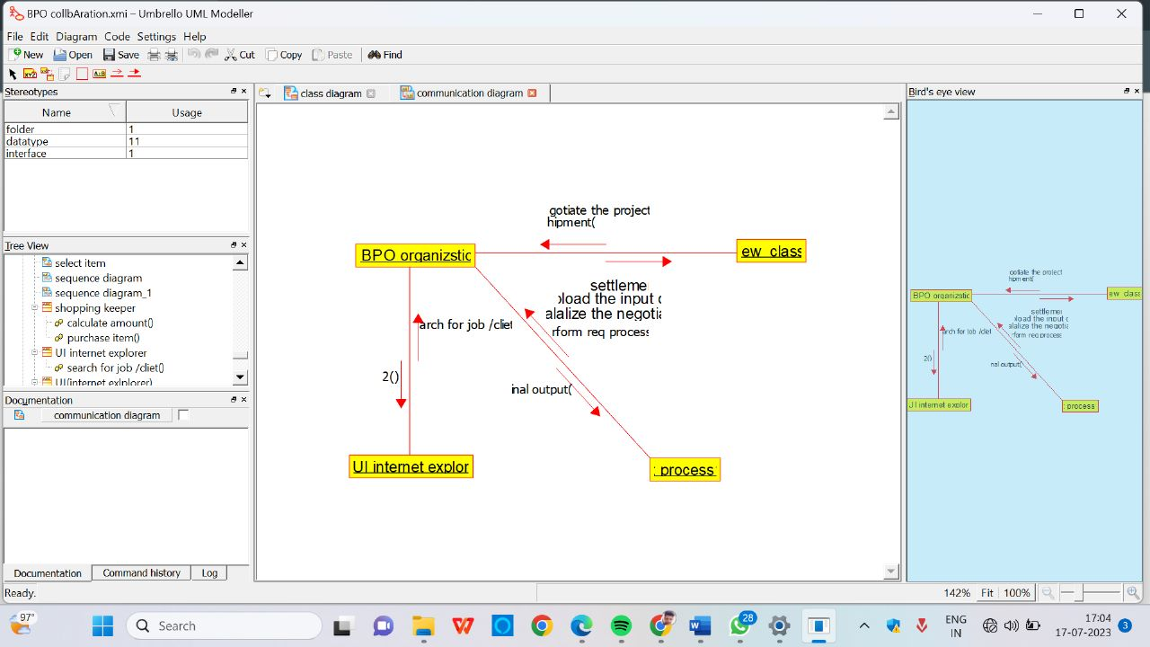

CLASS DIAGRAM

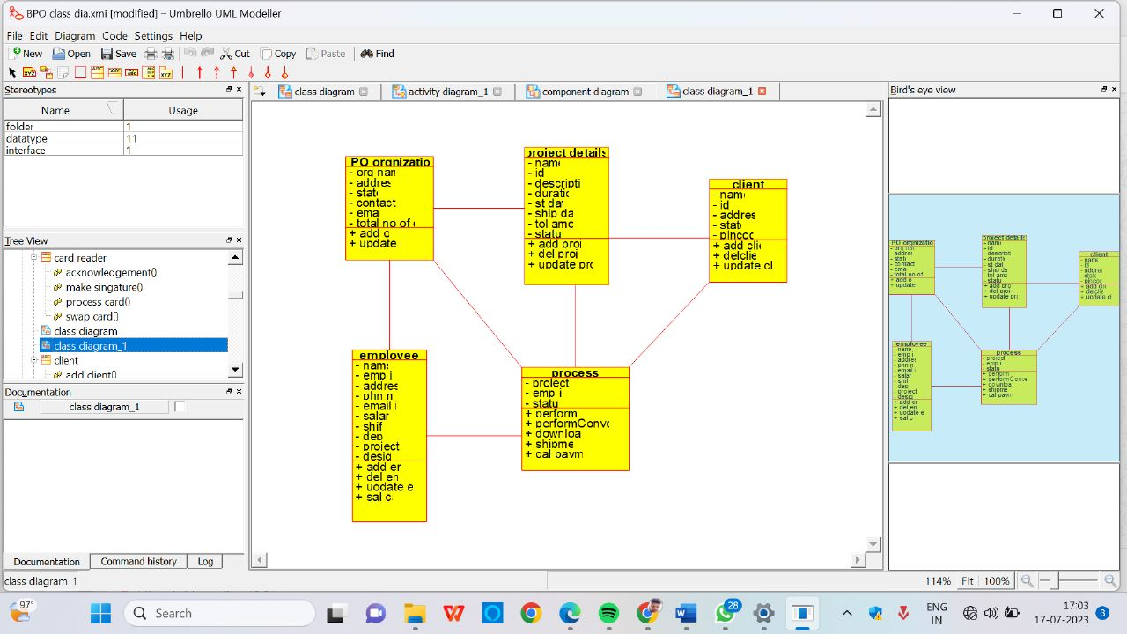

ACTIVITY DIAGRAM

